**Literature Review**

Any driver that frequents the University of Nottingham Malaysia Campus knows of the pain and hassle often involved in finding the ideal parking spot for the day, and it is often a case of the early bird catches the worm scenario. As students part of this problem, we sought out to better manage and frustrate drivers at the university, with the lack of prior knowledge of parking.

This project set out to create a wireless parking mobile system, which would save the drivers at the University of Nottingham loads of time often spent in not only finding a parking spot that is available but one that is also convenient, and to also assist in identifying their parking location.

From initial meetings and thorough discussions of all possible implementations, we decided that the most effective and environmentally friendly approach would be the following structure:

* **Old mobile devices which would act as sensors for the parking system**

These would be positioned above parking spots in the car park, and would be connected to a constantly on internet and power supply

* **An online based database**

This would be a virtual storage of the parking locations as well as the status of the parking spots, either being occupied or empty.

* **A mobile application**

This would be used as a point of interaction with the parking system.

It will show the statuses of the parking spots, as well as provide querying interactions, such as finding a parking spot that is at a convenient location and also saving the spot that they’ve parked at.

Based on the experiences and capabilities of the team, we chose to develop for the Android platform, along with a server-side script implementation to handle the map and pushing of real time map data to user’s phones. For the sensor, a mobile app would be built in Java that would use image processing techniques which would detect the presence of a car.

With this goal in mind, the following architecture and design was set out as the goal for the project:

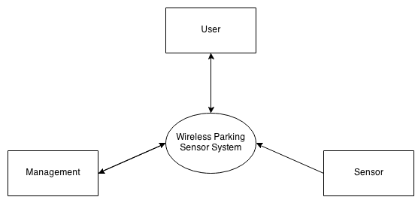

Context diagram

**Design:**

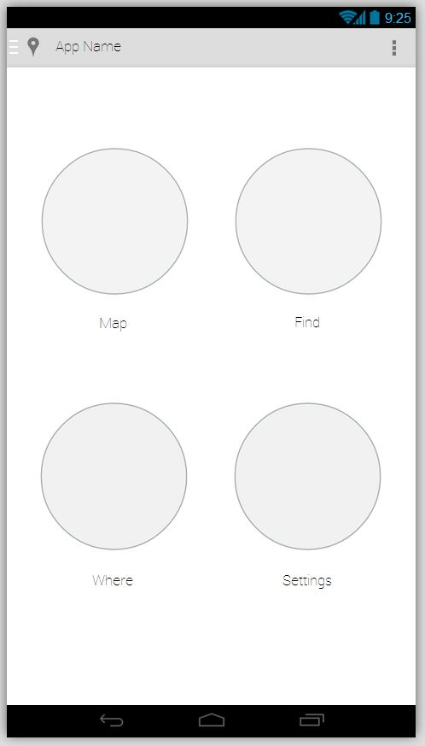

Main Menu

Simple 4 option plan that will lead to the main features of the application. The Side menu can be accessed by swiping from left edges or clicking on the icon on top left corner. Top left corner icon leads to settings page.

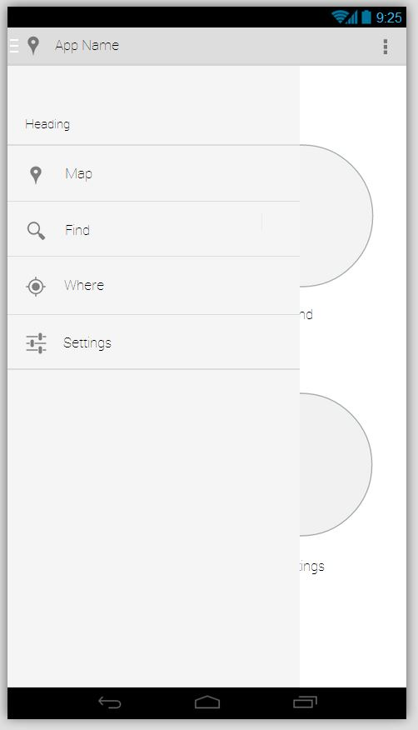

Side Menu

This is made up of a drop down menu which provides quick access to all the features of the application. It can be accessed by swiping from the left edge or by clicking on the top left icon.

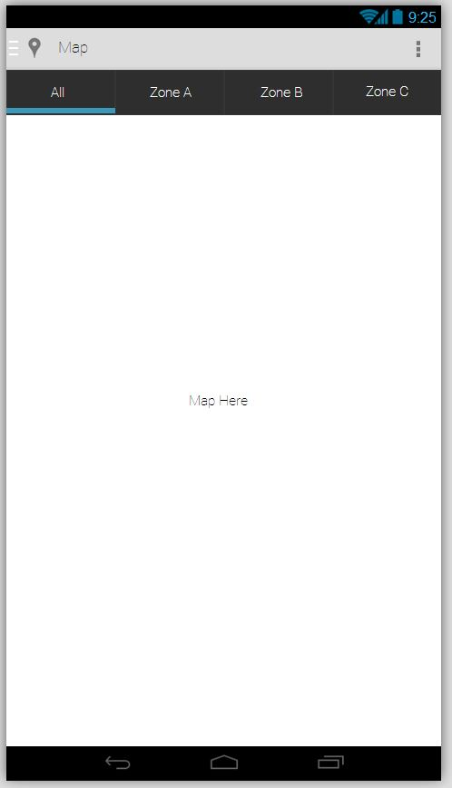

Map

The map will be separated into zones. The first “All” tab will display an overview map separated by zones. Each zone will display zone label and number of parking spaces left. When the user selects on one of the zones, it will lead to a detailed map of the zone itself with parking bays layouts and labels. The user could also navigate through the zones with the tab on the top. Users are also able to save their vehicle’s location by holding on a parking space for a few seconds and the system will prompt them to save it.

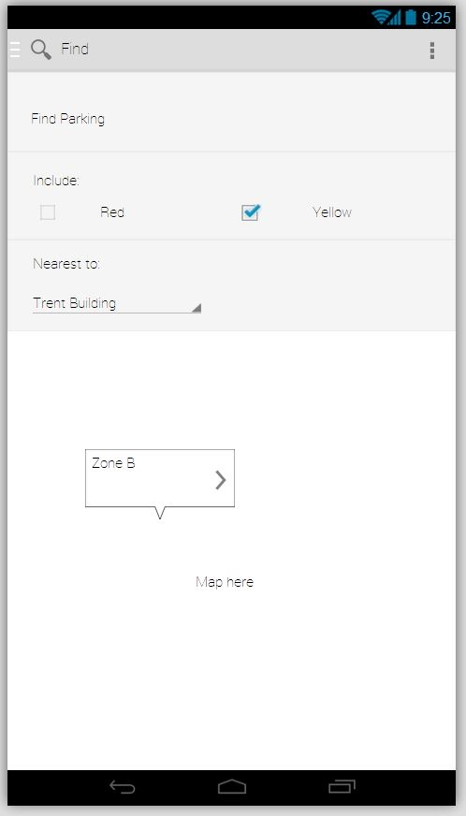

Find

The Find section of the application provides users with the ability to locate parking. Users are prompted to provide query arguments that are needed to search for nearest available parking. The lower bottom lays out a detailed map of the zone found to be closest and the free parking slot is labeled.

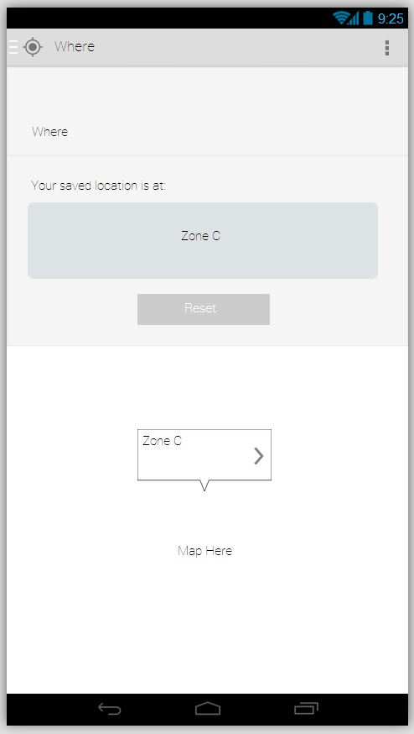

Where

The Where section of the application reminds the user where they have parked their vehicle. It shows the zone the vehicle is at and provides a detailed layout of the location on a map. There is also a reset button for the user to remove saved location.

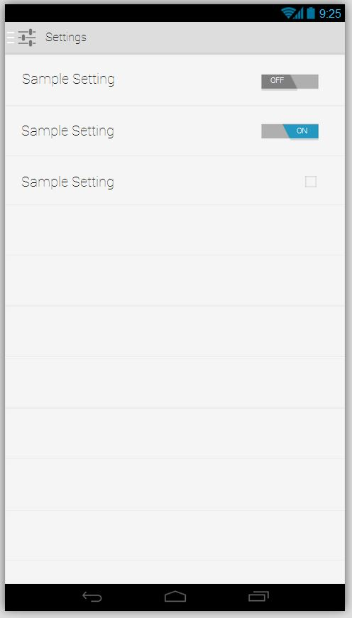

Settings

A simple list of sample settings with a display of sample graphical user interface toggle buttons and check box.

Following the decision of the platform and technologies to be used for this project the proceeding sections of the report details out what was achieved and how this was achieved.